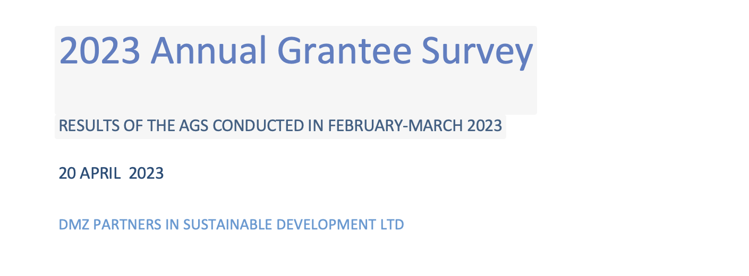

2023

Acknowledgements

We would like to thank all 131 OPDs that participated in the Annual Grantee Survey 2023. A response rate of 79% within a 17-day period is a reflection of their firm commitment as well as the strong relationship between DRF and the OPDs it supports.

We would like to express our gratitude to all DRF and OPD staff who contributed to the development and implementation of the survey and the testing of the online questionnaire.

Our special thanks go to Melanie Kawano Chiu for her consistent support in managing this year’s AGS and for mobilizing colleagues across the world and across different time-zones.

DMZ Partners in Sustainable Development Ltd

April 2023

# 

# Executive summary

In February-March 2023 DRF conducted the Annual Grantee Survey. In total 131 OPDs responded to the survey, resulting in a response rate of 79%.

The AGS 2023 was shorter than surveys in previous years. In addition to standard questions regarding diversity, the survey was used to seek input into the development of DRF’s new strategic plan.

OPDs were asked what they considered the key strengths of DRF. Based on the analysis of OPD responses, the following strengths were identified: capacity development (including organizational capacity in general and advocacy); its consistent focus specifically on OPDs; its focus on marginalized groups, including specific groups within the wider community of persons with disabilities; DRF’s funding mechanisms and processes; its focus on CRPD; the presence of competent and experienced staff; trust and equal partnership; communication; flexibility, creativity and innovation; the facilitation of learning; DRF’s long-term commitment and support; and DRF’s reputation.

Of the 82% of OPDs that had received funding from donors other than DRF, 93% indicated that DRF is somewhat or very different from other donors. The main differences that were identified include its focus on capacity building and institutional strengthening in general, and in particular for small and emerging organizations; its specific focus on persons with disabilities and OPDs; networking and learning; diversity and marginalized groups; communication; continuity of funding; and equal partnership.

Asked whether DRF should have a role in direct advocacy to advance the rights of persons with disabilities, 72% of OPDs responded ‘yes’. This was even higher in the Caribbean at 90%. First and foremost, however, OPDs emphasize that they see DRF’s role in advocacy as providing support to local and national, be it technical or financial. There seems to be broad consensus about DRF’s role in direct advocacy at international level, for example vis-à-vis UN agencies and donors.

Asked in which areas DRF could improve, the *provision of advocacy support* was identified most frequently, followed by *MEL, the provision of TA, grant-making processes, risk management support*, and *safeguarding support*, respectively. There are, however, regional differences.

Asked to rank DRF’s areas of work in order of importance, *grant-making* came out first, followed by *grantee-advocacy support* in second place, *technical assistance* in third place, *direct advocacy* in fourth place, *safeguarding support* in fifth place, and *risk management support* in sixth place. Regional differences in ranking, however, were identified.

Asked about changes in involvement of marginalized persons with disabilities, overall 98 (78%) of OPDs reported an increase, and 14% of OPDs reported a decrease in involvement. The decrease in involvement was reported by OPDs in the Caribbean (40%), Asia (17%) and Africa (12%). There was no significant different between OPDs *with* vs OPDs *without* a specific focus on marginalized groups.

Increased participation was observed in particular among deaf persons (who are underrepresented in some countries), followed by persons who are blind or partially sighted (who are underrepresented in some countries); persons with albinism; persons with psychosocial disability; persons who are hard of hearing or who have other hearing difficulties; persons with deaf-blindness; family members of persons with disability; persons with intellectual disability; persons with multiple disabilities; little

people; persons with epilepsy; and persons with autism. There are, however, significant variations between regions.

Looking at specific population groups, increased participation was observed in particular among women and girls with disabilities, followed by, youth with disabilities, indigenous persons with disabilities, LGBTI persons with disabilities, persons with disabilities living with HIV and AIDS, persons with disabilities from ethnic or racial minorities, and refugees with disabilities. Again, regional differences were observed.

Looking across the results of the survey, it highlights that DRF’s offer is a package rather than a single service. This is even more prominent when looking at Grantees that had received only one DRF grant, as this category of OPDs put even more emphasis on the importance of DRF’s contribution to capacity development. The support offered by DRF is **not a one-size fits all**. Instead, it is tailored to the needs and opportunities of individual OPDs as they continue to evolve.

Looking at both DRF’s strengths and the differences between DRF and other donors, it is clear that there is significant overlap. It highlights that the differences that set DRF apart from other donors are, at the same time, seen as DRF’s strengths. This constitutes important input into the development of DRF’s new strategy, as it gives DRF a strong foundation to further build on.

It is also noted that some of the areas for improvement identified coincide with the key strengths identified earlier. In other words, to build on the DRF’s strengths and differences with other donors, the results of the survey highlight the need for continued investment in support to OPDs and in DRF systems and processes, in order to further improves DRF’s performance in these niche areas as part of the development of DRF’s new strategy.

Asked about the future role of the AGS, OPDs identified *learning across the movement*; *capturing results and impact*; and *communicating DRF’s strategic focus and monitoring its implementation*. It highlights the need to consider the future role of the AGS in the context of a broader MEL framework and communication strategy, once DRF’s new strategy has been finalised.

# 

# Acronyms

|  |  |
| --- | --- |
| AGS | Annual Grantee Survey |
| CRPD | United Nations Convention on the Rights of Persons with Disabilities |
| DRF | Disability Rights Fund and the Disability Rights Advocacy Fund |
| OPD | Organization of Persons with Disabilities |
| PICs | Pacific Islands Countries |
| SDGs | Sustainable Development Goals |