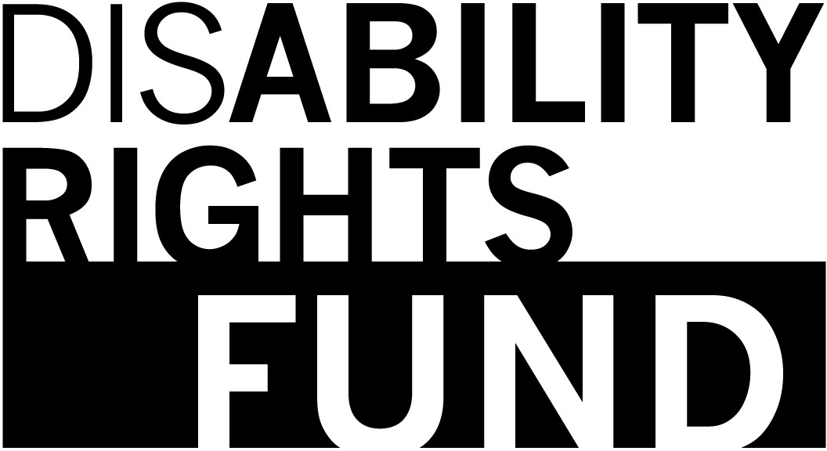

The DRF Plan to Stop
Sexual Abuse and Harm

Easy-to-Read Report

This report is about DRF's plan to stop sexual harm. It will explain sexual abuse, exploitation, and
harassment.

Sexual abuse happens if someone forces you, or tries to
have sex when you don't want to.

Sexual abuse happens if somebody kisses, or touches your body when you don't want them to.

Sexual abuse is against the law. It can happen to men and women, and also to children. If you have
been harmed, it is not your fault.

Some people might be more at risk of sexual harm because of their disability, age, gender, or religion.

Sexual exploitation happens
when somebody uses their power to have sex when you don't want to.

Sexual exploitation can happen with someone you know and
trust. This is not OK. It is not your fault.

Sexual harassment happens if somebody makes you feel unsafe, or ashamed by saying or doing something sexual.

Sexual harassment can happen anywhere. Sometimes it happens at work. It can make you feel
unsafe in your job.

DRF does not accept any kind of sexual abuse, sexual harassment, or exploitation.

DRF wants to keep everybody that works with us safe from sexual harm.

In 2019, DRF made a plan to help stop sexual harm. This plan is for anybody who works with us.

If somebody says that they were harmed, DRF will take it very seriously. We will look into it.

We will listen to the person who says that they were harmed. We will respect them and their human rights.

If somebody who works for DRF thinks they have been sexually harmed, they can make an
informal or formal complaint.

An informal complaint means that the victim will ask the person who is harming them to stop.

The victim can also tell their manager. They should only make an informal complaint if they feel safe.

A formal complaint is more serious. Victims should make a formal complaint if they feel
unsafe.

Formal complaints should be made to DRF Deputy Director,
Executive Director, or Executive Committee.

Everybody who works with DRF
needs to sign this form to say that they have read and understand DRF's plan to stop sexual abuse and harm.

I [Your name]

Agree to treat everybody at work with respect.

Agree that I will not say words that are abusive, sexual, or
disrespectful.

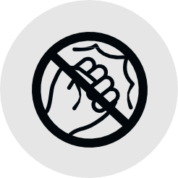
Agree that I will not sexually
harass or bully anybody at work.

I will do training on stopping sexual harm.

I understand that I should not cause sexual harm to anybody, and if I do, I may be disciplined.

Disability Rights Fund, 2020

