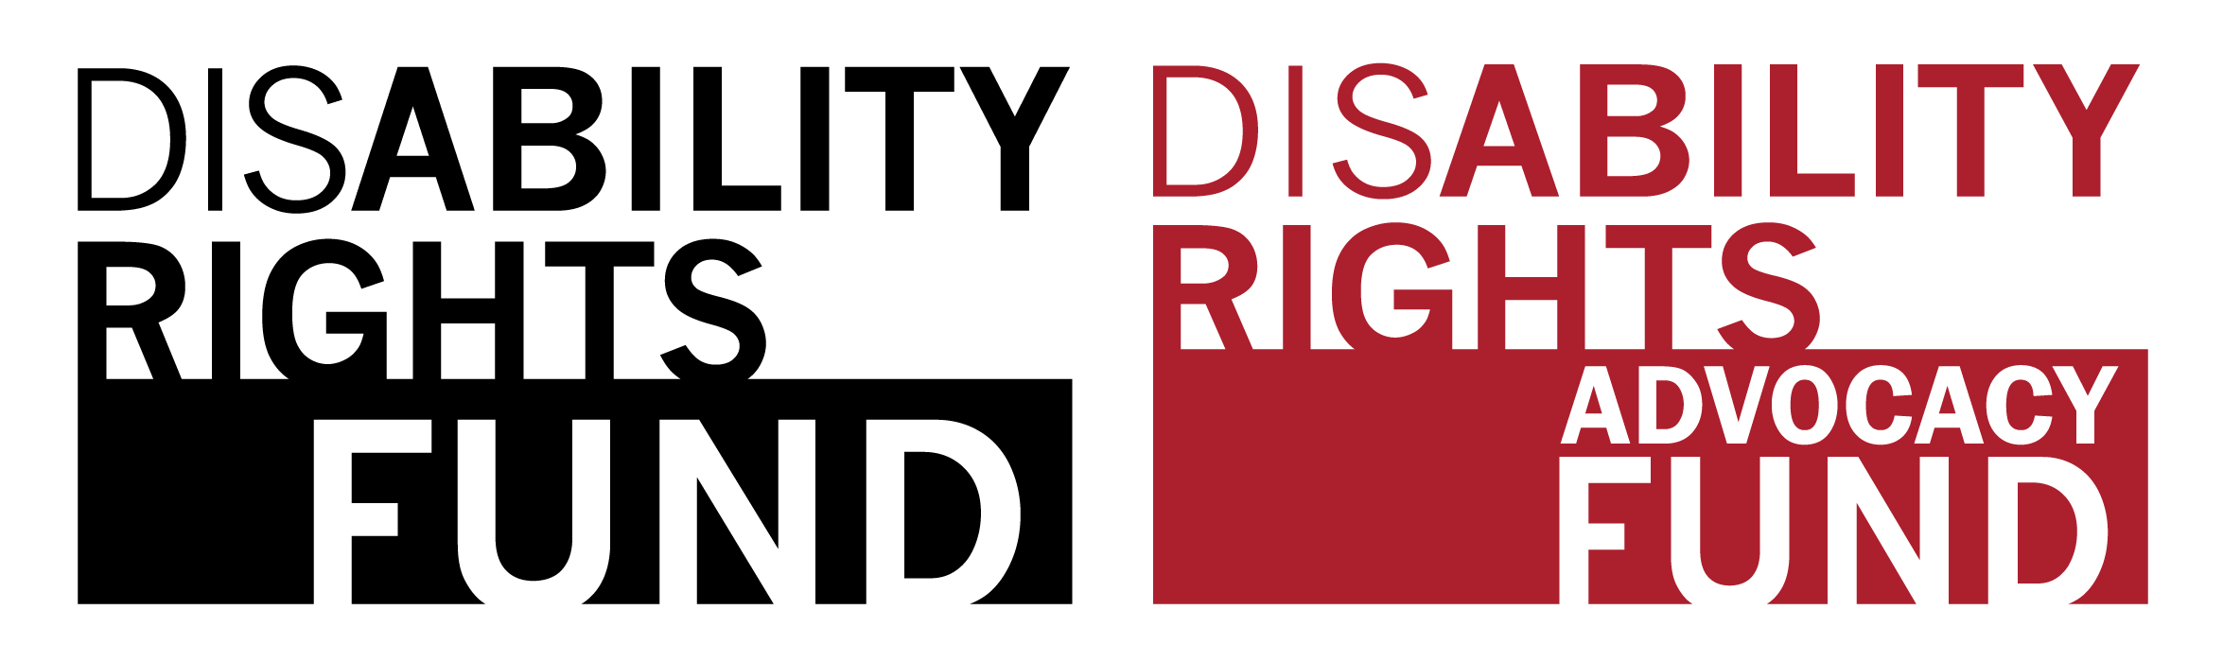

Fiscal Sponsor Organization Information Form
This form should be completed by all applicants working with a Fiscal Sponsor organization. The Fiscal Sponsor should complete this form, and return it to the applicant for inclusion in the main RFP submission.

Organization Background
- Legal Name of Organization (and Acronym):
- Type (e.g. NGO, OPD, CSO):
- Organization Mailing Address:
- Organization Telephone:
- Organization Email:
- Website:
- Year Founded:
- Location(s):
- Brief Description of Activities:
- Legal Registration Number:
- Registration Authority and Year:
- Registration Expiration Date:
- Can the organization receive funds from the United States?
- How long has the organization been working with the applicant?
- How long has the organization been providing fiscal sponsor services?

Organization Contact Person’s Information
- Full Name:
- Designation (Mr. Mrs. Ms.):
- Email:
- Job Title:
- Mobile Number and WhatsApp (if different):
- Skype Username:

Organization Governance & Policies
1. Are any members of your organization’s board of directors / governance employed by the organization?
If yes, please include names and titles.

2. Have any members of your organization’s board or staff ever been accused or convicted of any violation (such as fraud, financial mismanagement, child abuse, sexual misconduct)? If yes, please explain.

3. Policies: Please indicate whether your organization has the safeguarding policies below.
- Preventing Sexual Exploitation, Abuse & Harassment (PSEAH) Policy? __Yes __No
- Child Protection (CP) Policy? __Yes __No

Key Personnel
In the table below, please list the names, roles, and contact details of all personnel at the organization whose responsibilities involve management or oversight of finances and/or programs. Include relevant staff, volunteers, and all members of the Board of Directors or other governing body. Add more rows as needed.

Full Name | Role in the Organization  (e.g. Program Manager, Board Treasurer) | Role(s) outside the Organization  (e.g. Minister of Social Affairs, Board Chair of National Blind Union) | Contact Details  (email, phone, and WhatsApp or Skype)

