DISTRICT STAKEHOLDER MAPPING REPORT ON THE EDUCATION OF LEARNERS WITH VISUAL IMPAIRMENT IN RWANDA

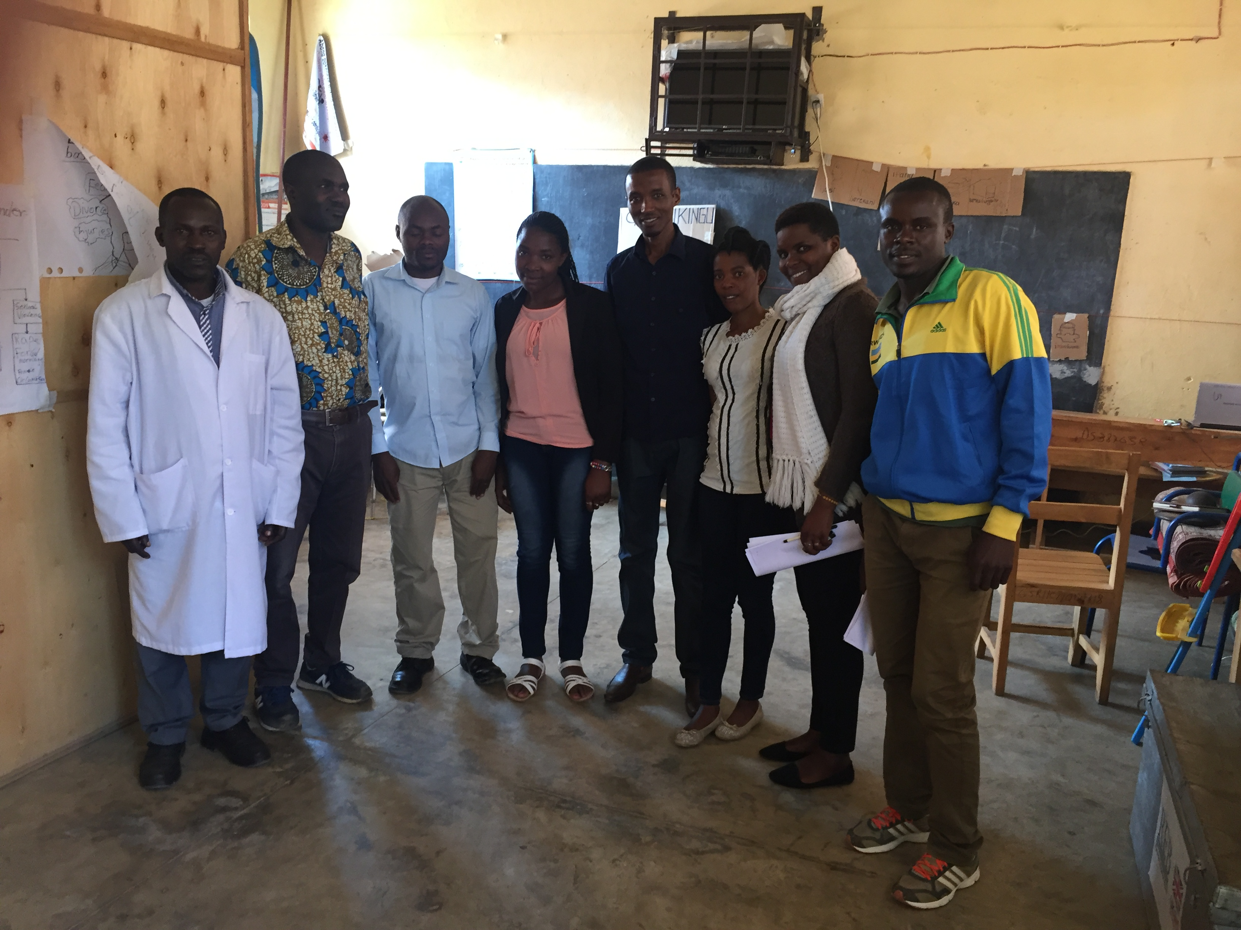

Respondent teachers at G.S Rukingu with 2 RUB staff

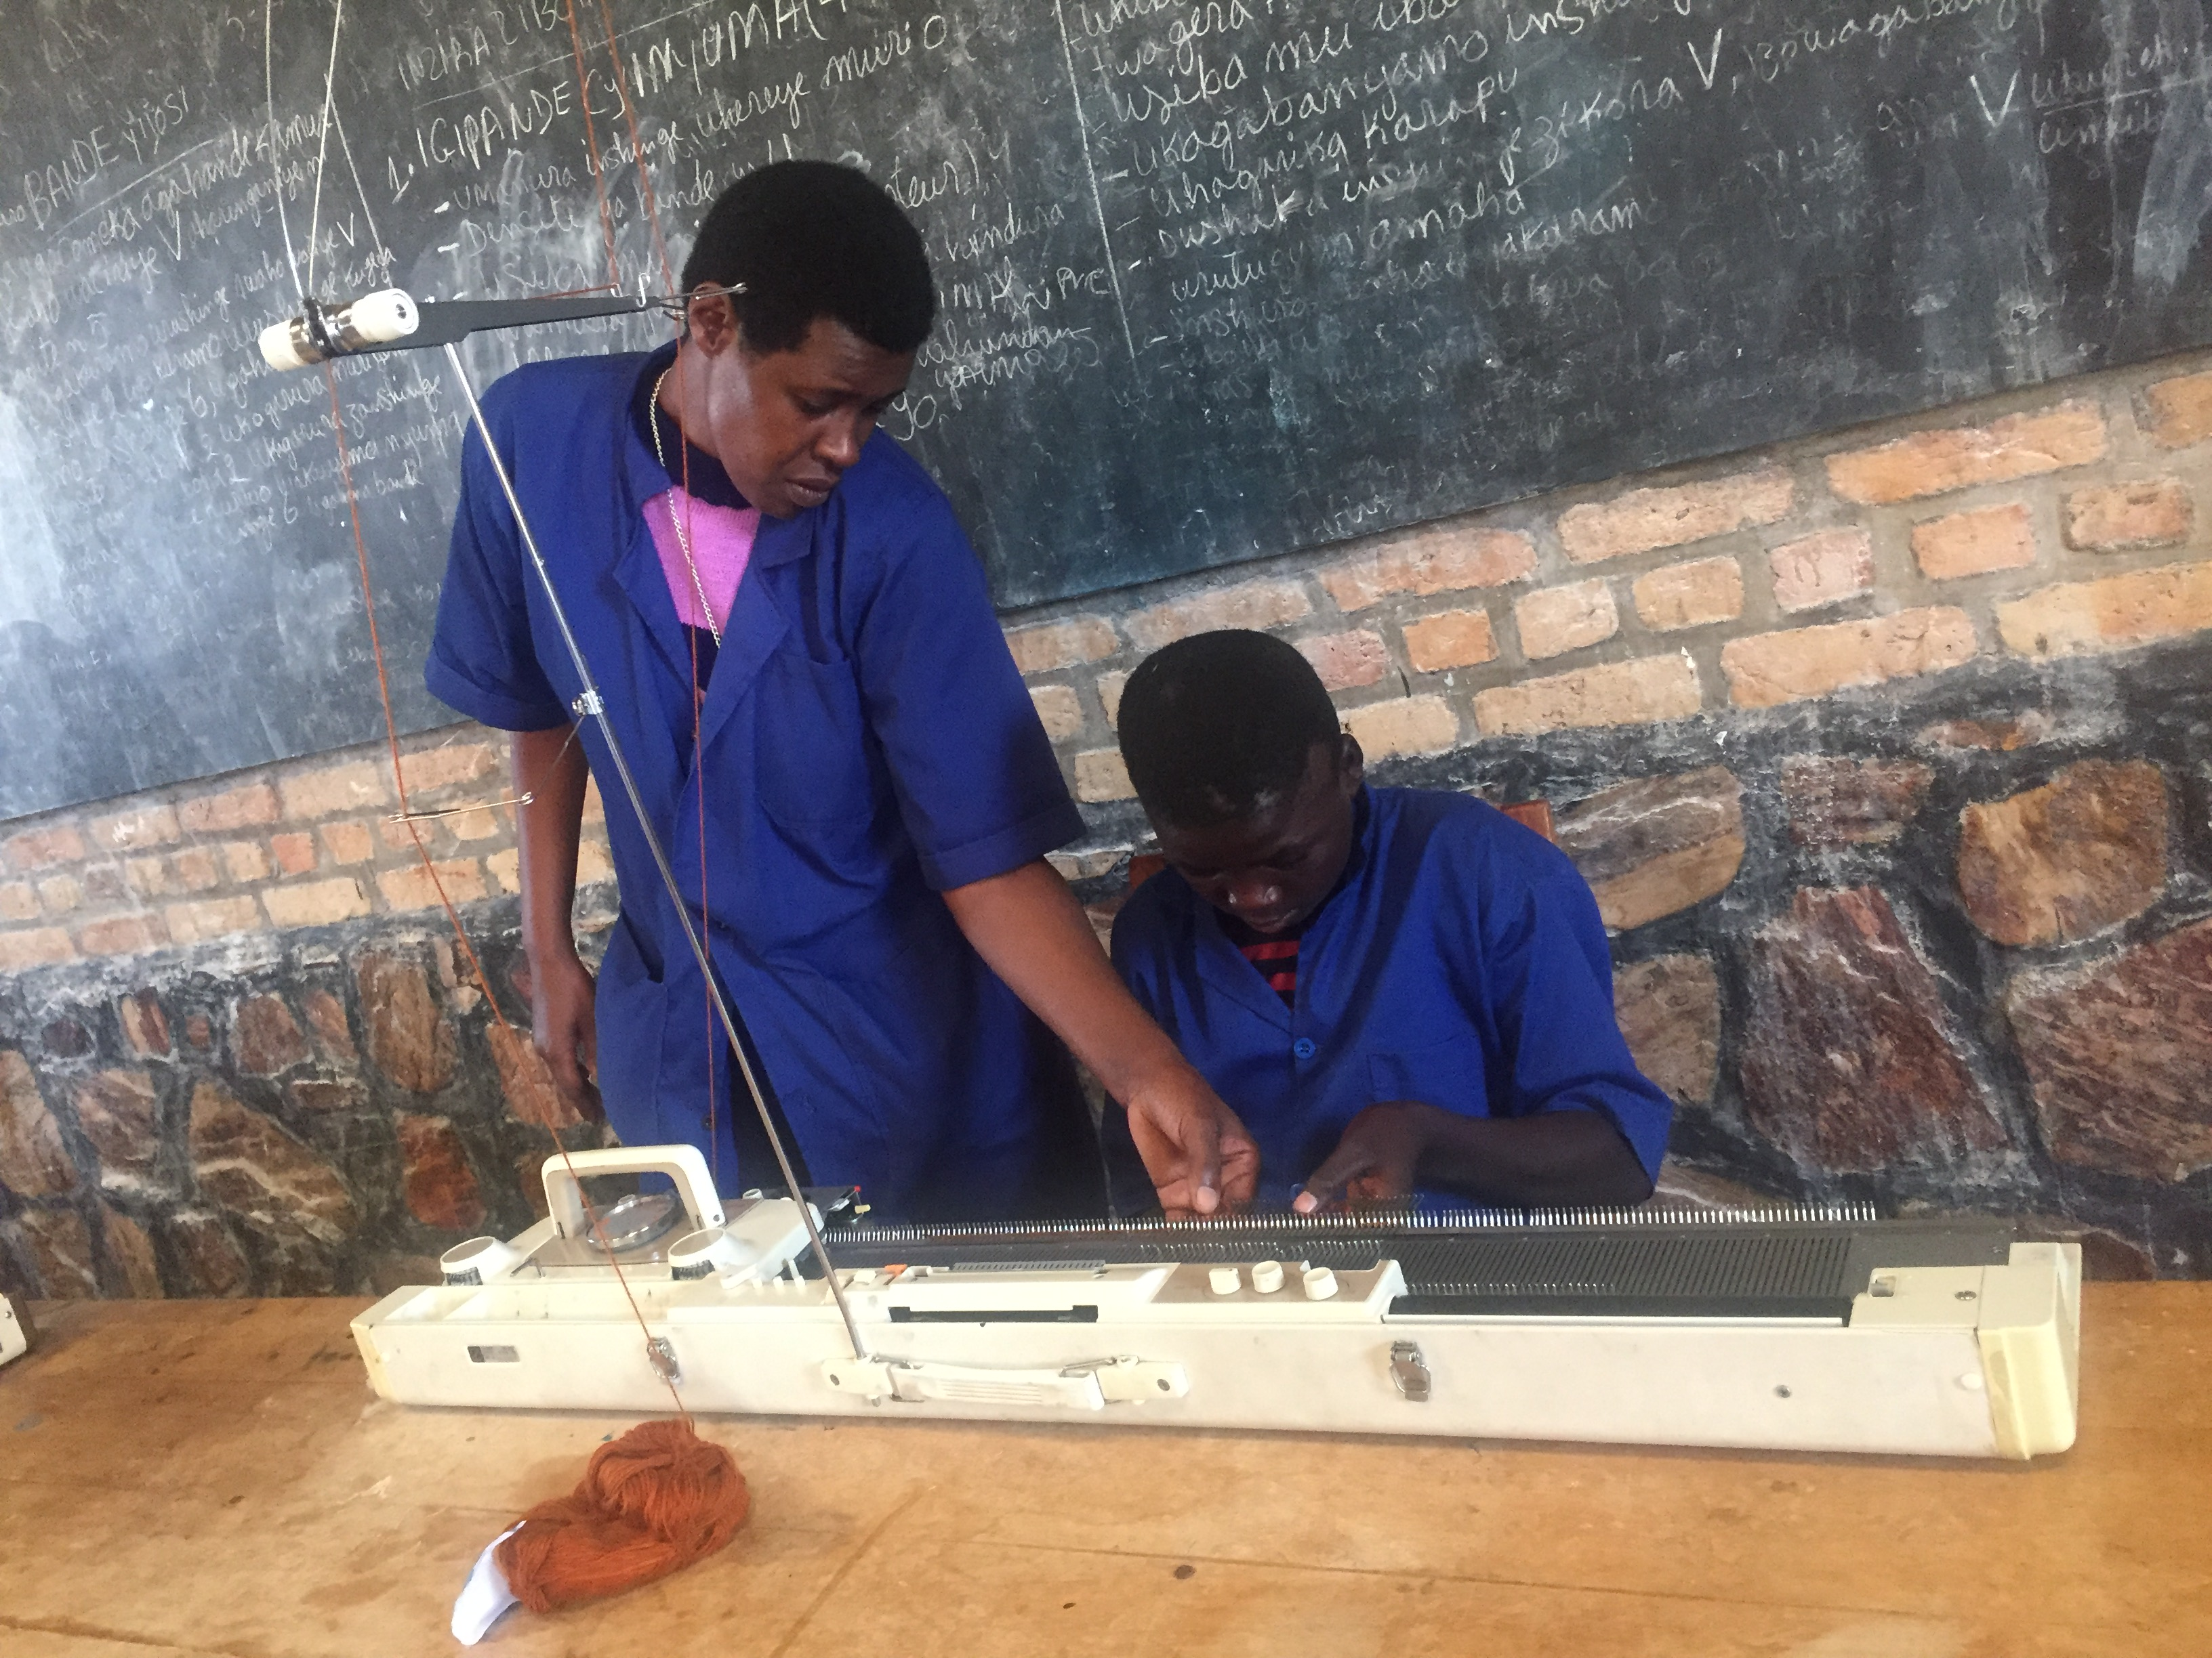
Trainees with visual impairment at VTC-Nyanza

DISTRICT STAKEHOLDER MAPPING REPORT ON THE EDUCATION OF LEARNERS WITH VISUAL IMPAIRMEN IN RWANDA.

Contents
Executive Summary - 3 -
I.Introduction - 4 -
ii. - 5 -
Scope and focus of the district stakeholder mapping - 5 -
II. Policies and Legal Framework - 7 -
i .International policies - 7 -
ii .National policies - 7 -
III. DISTRICT STAKEHOLDER MAPPING FINDINGS - 8 -
3.1 Enrolment of students with visual impairment - 8 -
IV. - 10 -
SCREENING OF Children with VISUAL IMPAIRMENT - 10 -
V.Educational Setting - 11 -
5.1 Special educational setting - 11 -
5.2 Inclusive educational setting - 13 -
5.3 Vocational training setting - 15 -
VI. - 15 -
Accessibility of educational tools and materials - 15 -
6.1.Curriculum - 15 -
6.2. Adapted textbooks and materials - 16 -
6.3. Assistive devices - 17 -
VII. - 17 -
Teacher Training - 17 -
VIII. Parent and Community Engagement - 18 -
CONCLUSION AND - 20 -
Recommendations - 20 -
REFERENCES - 22 -

ABREVIATIONS AND Acronyms

CBC Competency-Based Curriculum
CRC Rights of the Child
CRPD Convention on the Rights of Persons with Disabilities (United Nations)
CWVI Children with Visual Impairment
DPO Disabled Persons Organization
DRAF Disability Rights Advocacy Fund
DRF Disability Rights Fund
ESSP Education Sector Strategic Plan
GOR Government of Rwanda
IDA International Disability Alliance
IEPs Individualized Education Plans
HRBA Human Rights Based Approach
MINEDUC Ministry of Education
MINECOFIN Ministry of Finance and Economic Planning
MOE Ministry of Education
NCPD National Council for Persons with Disabilities
NGO Nongovernmental organization
NUDOR National Union of Disability Organizations of Rwanda
PWDs Persons with Disabilities
PDOs People’s Disabilities Organizations
PVI persons with visual impairment
REB Rwandan Education Board
RUB Rwanda Union of the Blind
SDG Sustainable Development Goals
SNE&IE Special Needs Education & Inclusive Education
SEN Special Educational Needs
TTCs Teacher Training Colleges
UNESCO United Nations Educational, Scientific and Cultural Organization
UNICEF United Nations Children’s Fund
URCE University of Rwanda College for Education
VTC Vocational Training Centres
WHO World Health Organization
SWVI Students with visual impairment

Executive Summary

The Government of Rwanda (GoR) has a significant commitment towards the improvement of the lives of persons with disabilities (PWDs) including those with visual impairment. This was enormously supported by the ratification of the United Nations Convention on the Rights of Persons with Disabilities (CRPD) in 2008 and the development of different domestic policies including the Special Needs Education &Inclusive Education policy.
This commitment motivates the work of Organizations of Persons with Disabilities (OPDs) in Rwanda including Rwanda Union of the Blind (RUB) to work towards the advocacy and protection of the rights of PWDs.
RUB uses the Human Rights Based Approach (HRBA) as part of its National Rights advocacy to address the denial of human rights to persons with visual impairment in Rwanda. It aims to legitimize the needs of persons with visual impairment as rights holders as declared in CRPD.
To ensure that RUB keeps serving as a watchdog for the realization of the rights of persons with visual impairment in Rwanda, and to hold the government accountable for its commitments towards inclusion of PWDs including those with visual impairment, RUB works to address the needs of persons with visual impairment and strives for the improvement of corresponding adequate legal and institutional framework.
In the year 2019, RUB has been awarded a grant by Disability Rights Advocacy Fund (“DRAF”) to implement a 1 year project entitled, “Advocating for accessible material for visually impaired persons in Rwanda’’ to advocate for accessibility printable format for the persons with visual impairment and for a new paradigm where the government authorities recognize their role and responsibility as duty-bearers and hence bound by the convention not only to be conversant with the articles, but also to institute the necessary mechanisms for the implementation of government commitments towards the 2018 Global Disability Summit, the Sustainable Development Goals (SDG), UNCRPD and ratification of Marrakesh treaty to enable intervention and realization of rights of persons with disabilities including those with visual impairment.

It is against this background that RUB conducted the district stakeholder mapping with the purpose of assessing the situation of the education of learners with visual impairment.
The overall objective of this assignment was to document the existing situation of the education of persons with visual impairment and provide situation analysis of the state of implementation of the Special Needs Education & Inclusive Education policy and the education for all program to indicate what is working and challenges facing learners/students with visual impairment in relation to the access to quality and equitable education. The district stakeholder mapping findings resulted in the documentation of a situation analysis of the education access of persons with visual impairments in Rwanda and further generated evidence on what is working, what is not working as well. Based on the findings, some recommendations for possible improvement and advocacy have been noted.

Findings and recommendations from this mapping will be used to broaden RUB’s understanding of the challenges and opportunities related to the education of learners with visual impairments in Rwanda, as well as assessing to which extent materials are accessible for visually impaired learners in Rwanda so that RUB can determine how best to structure its future interventions and advocacy.
The district stakeholder mapping involved a literature review of relevant materials and policies, data collection from 10 schools including (8 schools and 2 Vocational Training Centres (VTCs) that admit student with visual impairments. The report is organized into the following sections : (1) Introduction, (2) policies and legal framework; (3) District stakeholder mapping findings , (4) enrollment of student with visual impairment, (5) Screening of student with visual impairment; (6) educational settings; (7) accessibility of educational tools and materials, (8) teacher training; (9) parent and community engagement. The report also provides the general remarks and specific recommendations to relevant educational and disability institutions.

I.Introduction

The United Nations Convention on the Rights of the Child (UNCRC) stipulates that single child has the right to education. In line with this, the GoR has made a strong commitment to improving the quality education for all children including those with disabilities in the country. Different policies to allow for the inclusion of children with disabilities in education system is reflected in Special Needs Education and Inclusive Education (SNE&IE) Policy and in the Rwanda’s 2013/14-2017/2018 Education Sector Strategic Plan (ESSP) which had to prioritize the increase of equitable access to education for students with special educational needs within mainstream and special schools. The SNE&IE Policy intends to provide quality education to all learners who may, for any reason have temporally or permanent needs for adjusted educational services. The qualifying groups includes persons with visual impairment (PVI) among others. However, learners with special educational needs (SEN) have continuously experienced barriers in Rwandan Education system as they are often not provided with appropriate instructional resources, services and approaches. In particular, the learners with visual impairment are still struggling to access the quality education as all other learners with and without disabilities in Rwanda.

To better understand the current situation related to the education of learners with visual impairment in Rwanda, RUB as a watchdog organization for the realization of the rights of persons with visual impairment, under the support of the project funded by DRAF, conducted the district stakeholder mapping on the situation of education of learners with visual impairment in 10 schools/centers admitting learners with visual impairment.

- Methodology
RUB applied a mixed methodological approach that used both qualitative and quantitative data. The methodology included a literature review with a focus on key government policies, interviews with school representatives, questionnaires and focus group discussions with teachers.
Before data collection, RUB staff with experience in working with persons with visual impairment designed questionnaires and interview guides that helped to capture relevant information during the district stakeholder mapping assignment. Data collected through this process was analyzed and interpreted. Throughout the data collection period, the RUB team involved in data collection attempted to maintain a neutral attitude avoiding personal feelings, prejudgment, subjectivity and opinions.

ii. Scope and focus of the district stakeholder mapping
The district stakeholder mapping assignment involved a comprehensive mapping of 10 schools/ Centers providing education to persons with visual impairment in Rwanda. The selection of schools and VTCs based on pre-determined criteria rather than randomized. Data collection was also restricted to nine districts and focused on schools and VTCs identified as having taken specific steps towards educating persons with visual impairment in Rwanda. Despite the limitations, the assessment can serve as a basis for further action planning to address issues and barriers faced by learners with visual impairment. .

- Targeted schools and VTCS during data collection

No. | District | Sector | School Name | Type | Province
1. | Rulindo | Rusiga | GS Rukingu | Mainstream school | NORTH
2. | Nyagatare | Karangazi | GS Rwisirabo | Mainstream school | EAST
3. | Nyaruguru | Kibeho | Educational Institute for the Blind Children -Kibeho(EIBC) | Special school | SOUTH
4. | Rubavu | Gisenyi | Ubumwe Community Center(UCC) | VTC | WEST
5. | Ruhango | Ruhango | GS Ruhango Catholique | Mainstream school | SOUTH
6. | Nyanza | Busasamana | VTC Busasamana | VTC | SOUTH
7. | Rwamagana | Kigabiro | HVP Gatagara-Rwamagana | Special | EAST
9. | Kayonza | Gahini | G.S Gahini | Mainstream school | EAST
10. | Kayonza | Rukara | UR-College of Education | Mainstream university college | EAST

II. Policies and Legal Framework

i .International policies
Rwanda ratified the UNCRPD and its optional protocol on 15 December 2008. By ratifying the CRPD, Article 7 of the convention is devoted to children with disabilities and elaborates in detail on their human rights.
The GoR also committed to protect the rights of children by signing the United Nations Convention for the Rights of the Child (UN CRC, 1989), and its two Optional Protocols.
Furthermore, the GOR commits to providing inclusive education for all children with disabilities as well as to “facilitate the learning braille, alternative script, augmentative and alternative modes, means and formats of communication , orientation and mobility skills, facilitating peer support and mentoring” (United Nations, 2006, art. 24).
The Marrakesh treaty was adopted in 2013 in Morocco and this treaty entered into force in September 2016, but the government of Rwanda has not yet ratified the treaty so far. The treaty aims to facilitate access to published works through accessible formats for persons who are blind, visually impaired, or otherwise print disabled (World Blind Union, WBU).

ii. National policies
According to a 2008 African Decade of Persons with Disabilities report on the inclusion of persons with disabilities in Rwanda, a strong connection was noted between the international commitments and national legal framework in regarding disability inclusion.
The government committed itself through the adoption of the law to protect the rights of persons with disabilities (in 2007 - Law n° 01/2007 of 20/01/2007) and has passed eight ministerial orders in order to implement this law (in 2009).
As part of its commitment to the UN CRC, our Government took suitable measures in pursuance of children’s rights including the elaboration of the National Integrated Child Rights Policy (ICRP) in 2011.
The Rwandan constitution also has provisions with regard to persons with disabilities. Generally, its 16th article prohibits discrimination of any kind including discrimination based on disability and in its article 20, pledges government support with regard to education. The article stipulates that every Rwandan has the right to education, including learners with SEN (Government of Rwanda, 2015). In order to fulfill government’s commitments towards child’s rights and specifically the right to education for all, the Special Needs Education and Inclusive Education Policy and the National Integrated Child Right Policy were adopted.
The SNE and IE policy’s vision is the inclusion and optimum participation of all categories of learners with SNE within the full range of educational services provided in Rwanda, and the policy targets learners with SEN and/or learners who meet barriers within the ordinary Rwandan education system. The qualifying groups shall include Persons with Visual Impairment (PVI) among others.

III. DISTRICT STAKEHOLDER MAPPING FINDINGS

3.1 Enrolment of students with visual impairment
Rwanda has very high enrollment across the country. For primary schools, net enrollment rates have increased from 97 percent in 2013 to 99 percent in 2016 (Republic of Rwanda, 2016a). As indicated by the Education Statistical Year book, students with disability represent 7.5 percent, or 19,118 students, of the 2,546,263 total students enrolled in primary education and 17.2 percent are blind/low vision (MINEDUC, 2016). Unlike students without disabilities, girls with disabilities have lower enrollment rates, representing 44.4 percent, compared to boys with disabilities at 55.6 percent. This showcases a need to put more emphasis on the education of children with disabilities including those with visual impairment and the need to focus on education for girls with disabilities.

Learners with disabilities are less likely to remain in school especially as they advance in grades. It is estimated that very few students with disabilities are enrolled in secondary school (UNICEF, 2016). The number of students with disabilities graduating from primary school goes from 0.8% to 0.2% in tertiary education levels (Karangwa, E., 2017)
In Rwanda, Education of children with visual impairment is still new and it was mainly started by Catholic Church. Currently, only 14 educational institutes could admit children with visual impairment. 3 of these institutes specifically admit children with visual impairment, 7 are mainstream schools which can admit all children including those with visual impairment, two are higher learning institutions with a possibility to admit students with visual impairment and two VTCs with programs which could accommodate persons with visual impairment.
It has been found that the enrollment rate of CWVI is still low due to the available schools and centers which are still very few compared to the school age of CWVI in Rwanda, Parents and community mindset who mainly favor sighted children against those with visual impairment in education and the broader obstacle of poverty and inadequate school materials which continue to keep CWVI in isolation and solitude life.
Furthermore, the school environments and teachers who lack adequate skills on how to cater for children with visual impairment remains a big challenge for effective enrollment of CWVI. Actually, the enrollment of children in schools normally starts in kindergarten, however, in Rwanda there is no kindergarten which can admit children with visual impairment.
The table below summarizes enrollment rate of CWVI.
3.2. Enrollment of SWVI in 10 targeted schools and VTCs
No. | School Name | Type | TOTAL NUMBER OF STUDENTS | NUMBER OF SWVI | %
1. | GS Rukingu | Mainstream school
2. | GS Rwisirabo | Mainstream school | 1705 | 21
3. | Educational Institute for the Blind Children -Kibeho(EIBC) | Special | 134 | 134 | 100%
4. | Ubumwe Community Center(UCC) | VTC
5. | GS Ruhango Catholique | Mainstream school
6. | VTC Busasamana | VTC |  | 12
7. | HVP Gatagara-Rwamagana | Special | 162 | 162 | 100%
9. | G.S Gahini | Mainstream school | 915 | 25
10. | UR-College of Education | Mainstream school |  | 14

IV.SCREENING OF Children with VISUAL IMPAIRMENT
International best practice promotes the provision of routine vision screening for all children in the classroom. If children continue to struggle academically then additional, more comprehensive assessments are performed by trained multidisciplinary teams. These assessments identify both academic strengths and challenges and inform individualized education planning and determine what types of supports and accommodations a student may require.
Currently, there are no policies or \standardized tools or protocols related to the screening and identification of children with disabilities in Rwanda.
In the past, non-profit organizations such as the former Handicap International and Volunteer Service Overseas (VSO) have introduced screening tools into some mainstream schools but these efforts were not sustainable as the tools were not adopted by MINEDUC or MINISANTE nor routinely used.
Within 8 sampled schools and 2 VTCs which admit learners with visual impairment in Rwanda,vision screenings are not routinely performed in the classroom to assess if a child/a learner has a visual impairment.

RUB mapping findings showed that, the lack of both screening tools and trained professionals/multidisciplinary teams complicate the identification process of children with visual impairment in Rwanda.

The collected information from interviews held with school and VTC representatives revealed that the current methods used to screen children/learners with visual impairment are only the personal information and medical certificates from concerned children/learners. It was pointed out that this screening process is not adequate to capture all information which can help determine what types of supports and accommodations a student/ learner with visual impairment may require while being in classroom or at school. This also results to the confusion among educators to determine whether a child has a visual impairment or eye disease.

V. Educational Setting

5.1 Special educational setting
Education is a basic and fundamental human right enshrined in the Universal Declaration of Human Rights. According to the World Blind Union (WBU), education is considered to be an important means of socialization; it transforms a human being into a social being and is instrumental in improving the life situation of human beings and enhancing their livelihood opportunities.
The United Nations Convention on the Rights of Persons with Disabilities (UNCRPD) recognizes the right of all children with disabilities both to be included in the general education systems and to receive the individual support they need. Systemic change to remove barriers and provide reasonable accommodation and support services is required to ensure that children with disabilities are not excluded from mainstream educational opportunities. Article 24 of the CRPD stresses the need for governments to ensure equal access to an "inclusive education system at all levels", To provide reasonable accommodation and individual support services to persons with disabilities to facilitate their education. Article 24 also focuses on the education of children with sensory disabilities such as blind, deaf, deaf blind, partially sighted and others and stresses the need for specific support required for individuals on a case by case basis. The article reads as follows: “(c) Ensuring that the education of persons, and in particular children, who are blind, deaf and deafblind, is delivered in the most appropriate languages and modes and means of communication for the individual, and in environments which maximize academic and social development”.
The current global developmental agendas such as the Sustainable Development Goals (SDGs) and the AU’s Agenda 2063 all stress the need to ensure that development is inclusive and no one is left behind and many countries are putting their efforts to improve the lives of persons with disabilities, in different sectors of life including education sector.
Although the GOR has ratified the CRPD, which requires countries to provide inclusive education in Article 24, segregated educational settings for children with disabilities continue to exist and receive government funding.
The specialized schools that are supported by the Ministry are not evenly spread throughout Rwanda and — due to the small number of schools are insufficient to provide for the education of all children with disabilities in Rwanda (UNICEF, 2016). Most of the children with disabilities in Rwanda are cared for in centers which are run by inadequately qualified managers, and therefore do not necessarily offer appropriate educational services.” (Karangwa, E., 2017, pg. 247)
In Rwanda, there are only four special centres/schools admitting children with visual impairment and they are located in 4 provinces of the country; Eastern province-HVP Gatagara Rwamagana and G.S Gahini, Southern Province-Educational institute for Blind Children-Kibeho and Northern Province -Blessing School for the Visually Impaired.
All of these special centres/schools were established on the initiatives of faith-based organizations. Due to financial constraints, special schools receive a limited number of children with visual impairment and children admitted stay in the centers during the academic period as most of the children admitted come from far off places.
The funds that the special schools get from the government have been for a long time been limited to teacher salaries and very few materials. In addition to this, there is a lack of standardized braille which further complicate learners with visual impairment who would like to progress to higher education or those who may need to change from one school to another.
School representatives pointed out that most of those educational materials supplied by MINEDUC are inaccessible to children with visual impairment and it requires different school initiatives which include but not limited to transcription of text books into braille, audio and other accessible alternative modes in order to facilitate the teaching and learning process.

5.2 Inclusive Educational Setting
Nowadays, the world is committed to promoting inclusive education as a key strategy for the development of education for all programs.
In line with this vision, the GoR is also committed to the principle of promoting equalization of opportunities for all its citizens and in this regards, the SNE and IE policy was developed with provisions for learners with special educational needs.
According to WBU and International Council for Education of People with Visual Impairment (ICEVI), inclusive education is an approach and not a programme but a dynamic process that supports and welcomes diversity amongst all learners. It is a concept of effective schools where every child has a place to study and teachers become facilitators of learning rather than providers of information. Inclusion should be the broad goal and the ways to work towards achieving it are many.Typically, the present Rwandan SNE and IE policy was adopted as a response to the National Constitution of 2003 as revised in 2015, which articulates the right to education for all, including the most vulnerable groups (Article 20); also translated for implementation by the Seven Year Government Programme: National Strategy for Transformation (NST1) (Priority area no 4, 62)), and subsequently by the Education Sector Strategic Plan (ESSP - 2018/19-2023/24).
The SNE&IE policy has the objective of focusing on education provisions for learners with special Educational Needs in Rwandan special and/or inclusive education (public and private) settings.
Despite the initial stages of responding to SEN in Rwanda, children with disabilities including those with visual impairment are still facing different barriers to access equitable and quality education.
There are approximately 55 primary schools and 15 upper primary schools that are considered to be inclusive or child-friendly). Funded primarily by UNICEF, the former Handicap International implemented a project (2015-2018) with the objective to promote Inclusive Learning for Children with Disabilities in Rwanda and created model schools equipped with resource rooms
The district stakeholder mapping findings show that 4 among 10 targeted schools/centres are so called inclusive schools which means that these schools can admit children with visual impairment. However, it was noticed during the assessment that two of the four targeted so called inclusive schools have not admitted students with visual impairment so far due to a number of reasons including travelling long distance compared to where children with visual impairment are which requires that a child who may be admitted should alternatively find a rented shelter near the school to be able to reach the school on time and the community twined with parent mindset who favor sighted children against those with visual impairment. It was reported that due to geographical terraine of some districts, some schools are up hills and can’t be easily reached by children with disabilities including those with visual impairment especially when the support of grandparents is required to take the child to school. The case of Rulindo District in particular. Other findings show that all of the targeted inclusive schools are not well equipped to accommodate children with visual impairment as they don’t have any screening system, equipped resource rooms, trained personnel , accessible materials and no grounds for sport adapted to different types of disabilities: children with disabilities feel isolated when other are playing .
The school representatives also acknowledged that they had resource rooms from the support of different NGOs but some are not operational, others are rarely used. All of the school representatives interviwed acknowledged that the equipment in the resource rooms are not enough to help students with visual impairment; since, a well-equipped resource room can be very useful for during in-service training on the education of children with visual impairment as they ought to be equipped with alternative format materials ,teaching aids, assistive devices etc.

In general, children who are mainstreamed do not receive additional supports but instead they are expected to adapt themselves to the environment and the schools having children with visual impairment are not given any special consideration when it comes to materials distributed by REB or concerning any other type of government funding.
At tertiary education level, one higher learning institution; UR-Rukara college of education was targeted during the district stakeholder mapping, and findings seem to be the same concerning the educational situation in all angles as it is in primary and secondary education levels.

5.3 Vocational Training Setting

Promoting equality of access to the education system is generally understood as allowing flexibility in the different stages of the education system and providing resources by adapting programmes to each learner’s capacities.

In many countries, this involves focusing on programmes in which learners with special educational needs are actively engaged. These programmes give young people the opportunity to experience a range of vocational areas. However, in Rwanda there is no any national policy where an inclusive learning path for learners with disabilities is a regular option in vocation education training.

In Rwanda, there is Technical and Vocational Education and Training (TVET) that includes Technical Secondary School (TSS), which last 6 years with A2 level and the Vocational Training Centres (VTCs) with certificates after the training. Teaching skills in the area of any career education must provide students without any distinction with the opportunity to learn for his/her future development. It is rare that children with disabilities finish A2 and continue in TSS. To date, there are few cases of persons with disabilities attending VTCs due to the fact that the existing VTCs are not disability friendly.

Currently, there are only two VTCs (one private and another government funded) which can admit people with visual impairment to learn vocations. Despite these initiatives put in place, the stakeholder mapping findings revealed that there is no plan in place to promote the professional development of teachers in meeting special educational needs of learners with visual impairment in VTCs, materials are not provided to meet learners’ needs, no assistive devices to support their movements within and centres and these are combined with lack of conducive environment.

VI. Accessibility of educational tools and materials

6.1.Curriculum
In 2016, the Competency-Based Curriculum (CBC) was launched in all Rwandan pre-primary, primary and secondary schools. This curriculum considers the needs of learners with special education needs in mainstream schools and focuses on academic content. Specifically, the CBC states that “teaching and assessment strategies must ensure that no learner is placed at a disadvantage on the grounds of gender or special needs” (MINEDUC, 2015, pg. 23). In addition, “the full curriculum needs to be accessible to every learner, rather than having lower expectations for those with impairments and disabilities” (MINEDUC, 2015, pg. 23). This approach of having access to the full curriculum follows the international best practice. The curriculum should be modified or individualized yet consistent with the national curriculum instead of providing alternative curriculum to students with disabilities.

It has been revealed during the district stakeholder mapping that, the current curriculum in use has not been adapted according to the universal design since it does not fully meet the needs of learners with disabilities especially those with visual impairment. Teachers acknowledge that for many cases, it is found that the curriculum did not plan anything to support teaching process when it comes to a child with visual impairment. The typical example is that it is not easy for a teacher to teach mathematics to a child with visual impairment as it is not indicated in the curriculum how a child can be taught mathematics. In addition to this, instructors are not given any teaching material accessible to a child with visual impairment. All examples used and methods available in the curriculum seem to be useful to sighted children.

In order to cope with labour market demands, the Workforce Development Authority (WDA) in collaboration with REB developed national TVT but the curriculum being used in TVTs and VTCs is not adapted to learners with visual impairment whereby instructors/teachers deal themselves with different methods to transfer skills to learners.

6.2. Adapted textbooks and materials

The lack of accessible textbooks, adapted teaching / learning aids and other educational materials in accessible formats remain a problem within the regular educational and TVT settings. Often for the schools which receive the government funding, they are also provided with some equipment but lack of consultations with the schools on the appropriate and required materials/equipment that meet the learners’ needs make some materials or equipment distributed to be irrelevant in the special schools targeted.
Audio books, Perkins Braillers, the slate and stylus, large print materials, and pictograms are typically not provided to students who need them in mainstream classrooms. The schools for the blind and a few other schools equipped with resource rooms have access to assistive devices to support education, such as the slate and stylus, Perkins Brailler provided by outside Rwanda donors. However, none of the schools visited had audio books while audio books are essential for people with visual impairment to easily access printed information

6.3. Assistive devices

Assistive devices are believed to increase participation, achievement or independence for a student with disability. The goal of assistive technology is to give children with disabilities access to literacy and communication in the school, home, and community. For those with visual impairment, assistive devices support them to perform academic tasks and increase their active participation in the classroom. The provision of white canes and other essential assistive devices for learners with visual impairment are not available in both special and mainstream schools to support students with visual impairment. These are usually provided by parents or charity organizations rather than by the Ministry of Health or schools.
Most of informant teachers in the district stakeholder mapping acknowledge that they lack assistive devices to support teaching and learning process of learners with visual impairment as well as knowledge of these technological assistive devices which makes it dificult for them to support quality education for the learners with visual impairment.

VII. Teacher Training
To meet the needs of learners, there should be in place policies, procedures, and provisions designed to equip teachers both those in formal education and those in vocational Education training programs with relevant knowledge, attitudes, behaviors, and skills they require to perform their tasks effectively in the classroom, school, and wider community. In connection with this, it is also essential that the professional development of teachers is promoted in order to facilitate them meet the special educational needs and encourage their involvement in inclusive programme.

The information collected during the district stakeholder mapping from special, mainstream schools and VTCs indicate that there is inadequacy of trained teachers in schools in the field of special Needs education and even those who complete studies in Teacher Training Centers (TTCs) do not have technical skills to educate children with visual impairment. It seems that teachers graduating from TTCs can only serve for schools which are not inclusive or which do not have children with visual impairment. Most of the teachers confirm to have received inadequate training and others did not receive any to enable them fully support children with special needs in classrooms. A few teachers have some knowledge in vision impairment to be able to deal with the diverse challenges that both mainstream and special teachers may encounter in relation to the education of children with visual impairment.

Special school representatives urged that teachers for special schools typically only receive specialized training once they are employed by the school. As a result, many teachers in the schools for the blind only have some knowledge but not proficient in braille and other alternative modes of teaching. The district stakeholder mapping findings showed that the number of teachers who received training on inclusive education vary significantly by school, with some schools receiving no training to other schools receiving one week or a single day training. Most of the school representatives and teachers involved in this mapping, do not feel the training provided was enough to educate children with visual impairment as all concerning the education with visual impairment requires more time.

VIII. Parent and Community Engagement
Parents’ positive attitude towards child’s education is important in determining school attendance and academic achievement of the child. Favorable attitude towards schooling and education enhances parental involvement in children’s present and future studies. The information collected from teachers and school representatives during the district stakeholder mapping in regard with parent engagement in the education of their children indicate that most of parents of children with visual impairment are not interested in the education of their children while parental engagement in education is a key to the success of all children, including those with visual impairment.
In the contrary, it was reported that on one hand many parents still have the negative attitudes which underestimate the talents and potentials of children with visual impairment and some prefer to favour sighted children against those with visual impairment. On the other hand, there are parents who consider their children as burdens and when they bring their children to the residential school, they think that they are relieved of those burdens and do not think to keep in touch with the school to monitor the progress of their children.
In addition to the role of parent in the education of children, also is the community attitudes which matters to motivate the child at school.
The findings of the stakeholder mapping showed that there persists the community negative mindsets which discourage the education of children with disabilities. When the community members negatively criticize the ability and potentials of children with visual impairment in schools, students with visual impairment are in danger of hating education, and therefore, limits their opportunities for future progression.

GENERAL REMARKS
The UNCRPD in its Article 24, recognizes the right of all children with disabilities both to be included in the general education systems and to receive the individualised support they might require in order to participate effectively in the education system. Systemic change to remove barriers and provide reasonable accommodation and support services is required to ensure that children with disabilities are not excluded from mainstream educational opportunities and the current global Sustainable Development Goals put emphasis on the principle of leaving no one behind in all development programs.
With these principles, the GoR has a political will to promote the rights of persons with disabilities including those with visual impairment. The right to education for children with disabilities among other rights have been a government concern since last 5 year to date with the aim to offer equal rights to education to all children by putting different policies and strategies to promote inclusive education.
Despite progressive work towards disability inclusion in Rwanda, hence the RUB mapping findings revealed that there are still some gaps to be filled in related to accessing the right to education by children with visual impairment:
- Lack of screening system to facilitate identification of children with visual impairment during enrolment
- Negative attitudes of family members and community which underestimate the talents and potentials of children with visual impairment,
- Lack of capacity and efficiency of teachers to deal with the unique and specific educational needs for education of children with visual impairment and issues such as orientation and mobility skills, braille, use of assistive devices and technology to support children with visual impairment in regular schools;
- Lack of standardized braille in schools educating children with visual impairment in Rwanda
- Lack of inclusive recreational facilities: the findings showed that children with visual impairment are still lacking playgrounds, equipment and training to do some sports such as goal ball, etc.
- Lack of textbooks and learning materials in accessible formats such as braille, large print, audio, electronic and other appropriate formats in regular schools;
- Accessibility, affordability and availability of assistive devices and technology for children with visual impairment as well as training in their use;
- Incompatible education systems such as curriculum and other teaching and learning materials
- Lack of early learning centres for pre- schooling and nursery as it is planned to all other children to prepare them for proper education. Currently, there is no pre-primary school/nursery which can admit a child with visual impairment in Rwanda
- Inadequate VTCs which can admit persons with visual impairment

CONCLUSION AND Recommendations
RUB as a watchdog organization for the realization of the rights of persons with visual impairment in Rwanda and based on the findings of the conducted district stakeholder mapping, therefore propose the following recommendations to different institutions working in educational area:
- To promote policies supporting an inclusive system in all education setting areas allowing for flexibility in both accessing and delivering vocation education training with adequate human and individualized resources (i.e.: assistive and technology, mobility tools, and financial support)
- To develop identification tools to help screening process during enrollment of children with visual impairment in order to plan the way forward according to the situational needs of identified/screened child.
- To promote professional development of teachers in service and those in Teacher Training Centres in meeting special educational needs and encourage their involvement in inclusive program,
- Equip regular schools with accessible educational materials that support all children including those with visual impairment;
- To conduct continuous sensitization activities aimed at changing attitudes and behaviors in communities in order to achieve an inclusive and supportive society towards the education of children with visual impairment
- Put more emphasis on accessible learning and teaching materials to facilitate the education of all learners including those with special needs through ratification of the Marrakesh treaty to facilitate the accessibility of printable formats.
- Establishment of a regulatory institution / department for regulating education materials for persons with visual impairment (PVI). A regulatory institution / department should be established to regulate education materials for PVI. This should include the provision of standardized Braille formats to be used in Schools all over the country.
- Train technicians specialized in reparation of teaching materials and equipment for PVI
- Equip technicians with skills to specialize in repairing of special teaching equipment and technical devices used by persons with visual impairments in education.

REFERENCES

- Hayes, A.M. & Bulat, J. (2007). Disabilities Inclusive Education Systems and Policy in Resource-Constrained Environments: A Practitioner’s Guide. Research Triangle Park, NC: RTI Press.
- International Council for Education of People with Visual Impairment and World Blind Union, (2016) Joint Responds to the CRPD’s Committee’s Draft General Comment no. 4 Article 24 The Right to Education.
- Jokinen, M. (2015, April 15). Interactive panel on non-exclusion on the basis of disability, reasonable accommodation and access to inclusive education systems. Speech presented at Day of General Discussion, UN OHCHR Committee on the Rights of Persons with Disabilities (CRPD) in Geneva, Switzerland.
- Karangwa, E. (2017) Republic of Rwanda. In M.L. Wehmeyer & J.R. Patton (Eds)The Praeger International Handbook of Special Education (pg. 240-254). Santa Barbara, CA. Preger.
- National Institute of Statistics of Rwanda(2012) Rwanda Population and Housing Census.
- The Republic of Rwanda (2007) Special Need Education Policy.
- The Republic of Rwanda, Ministry of Education (2010) Education Sector Strategic Plan (ESSP) 2010-2015.
- The Republic of Rwanda, Rwanda Education Statistics (2012)
- The Republic of Rwanda, Ministry of Education (2013)Education Sector Strategic Plan (ESSP)2013/14-2017/18.
- The Republic of Rwanda (2015) The Constitution of the Republic of Rwanda of 2003 Revised in 2015.
- FHI 360 (2014) Rwanda: National Education Profile 2014 Update
- The Republic of Rwanda, Ministry of Education (2016a) Educational Statistical Yearbook.
The Republic of Rwanda, Rwanda Education Board (2016b). Guide to Inclusive Education in Pre-primary, Primary and Secondary Education.
- United Nations. (2006). The Convention on the Rights of Persons with Disabilities
- United Nations Children's Fund (2016) A Study on children with disabilities and their right to education: Republic of Rwanda.
- United Nations Office of the High Commissioner for Human Rights (OHCHR). (2017).Ratification Status by Country or Treaty.
- World Health Organization. (2011). World Report on Disability.
- World Intellectual Property Organization (WIPO). (2017). List of Ratification of the Marrakesh Treaty.

http://www.worldblindunion.org/english/news/Pages/The-Treaty-of-Marrakesh.aspx

